TASK – 1: Creating Git Repository and Folder Structure

Name: Thakur Akshay
Enrollment No: 2402031000044
Subject: Web Technology with UI/UX
Course Code: 2010043228
Semester: 4th IT A-1

Step 1: Create a GitHub Account
In the first step, I visited the GitHub website and registered a new account using my email address. After completing the sign‑up process and verifying the email, I logged into my GitHub account successfully.


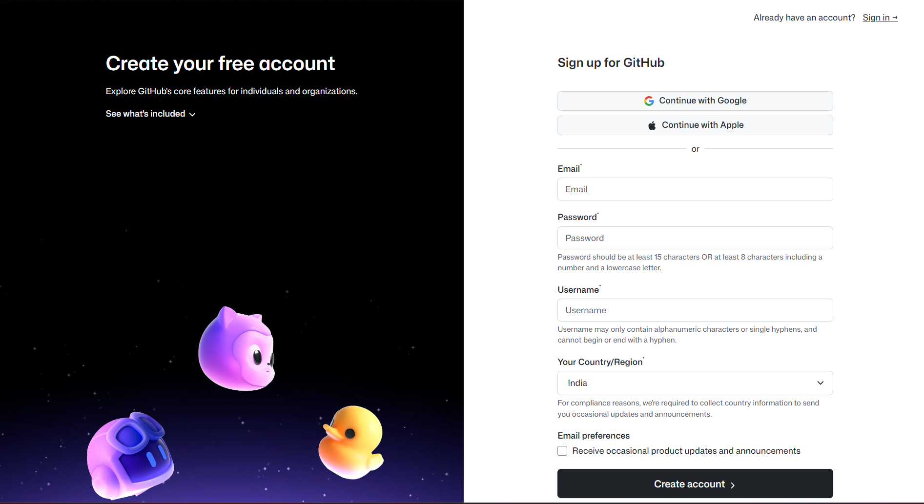

Step 2: Create a Repository
After logging into GitHub, I created a new repository. While creating the repository, I used my Enrollment Number as the repository name so that it can be easily identified.
Repository Details:
Repository Name: (2402031000044)
Visibility: Public
Initialize repository with README file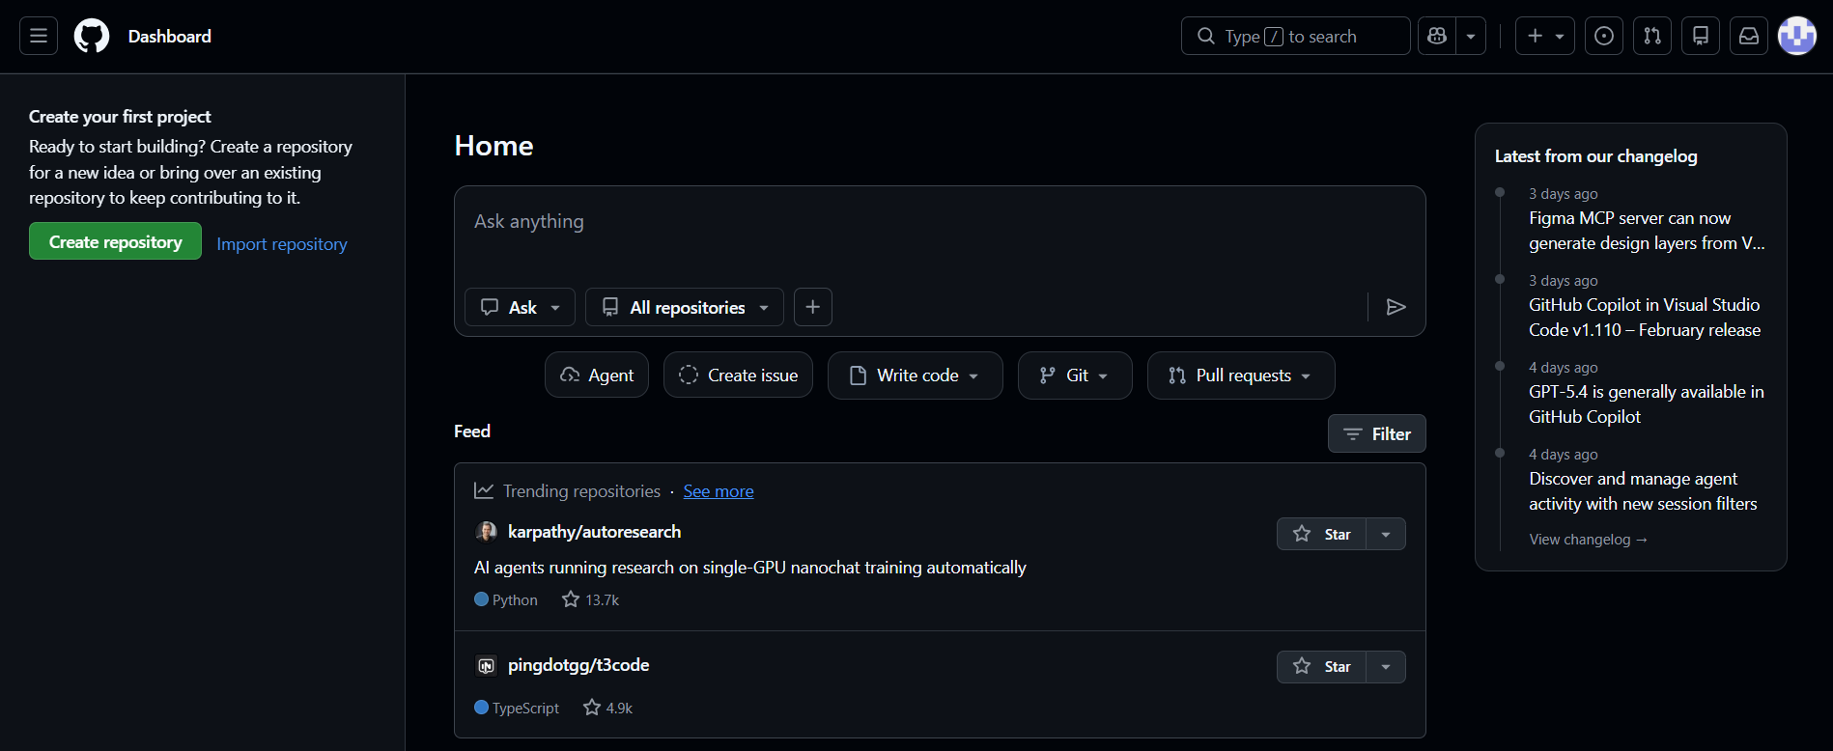
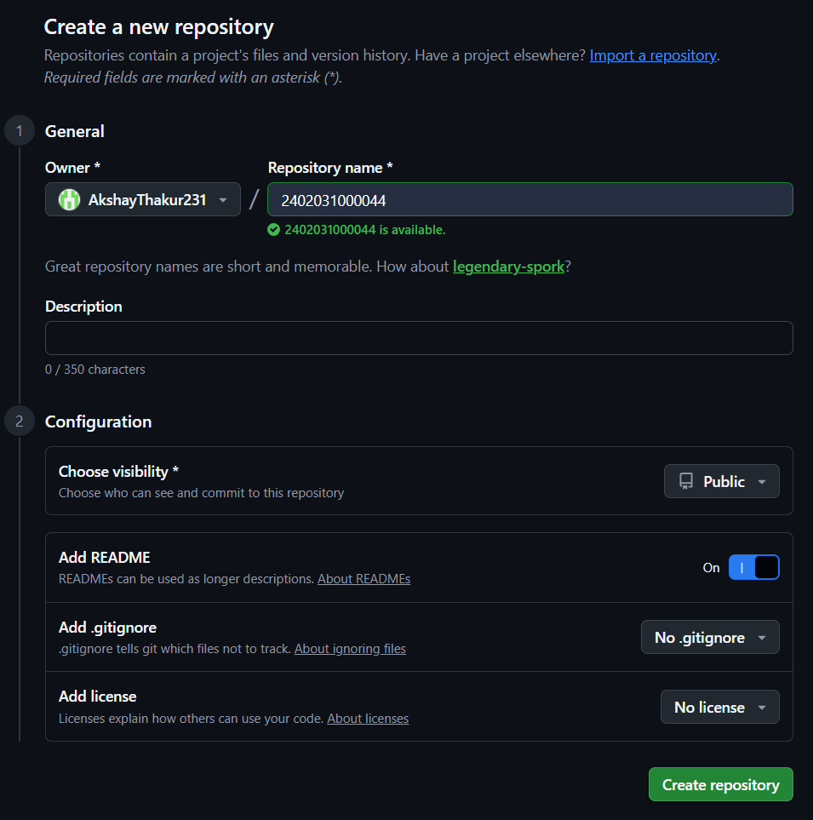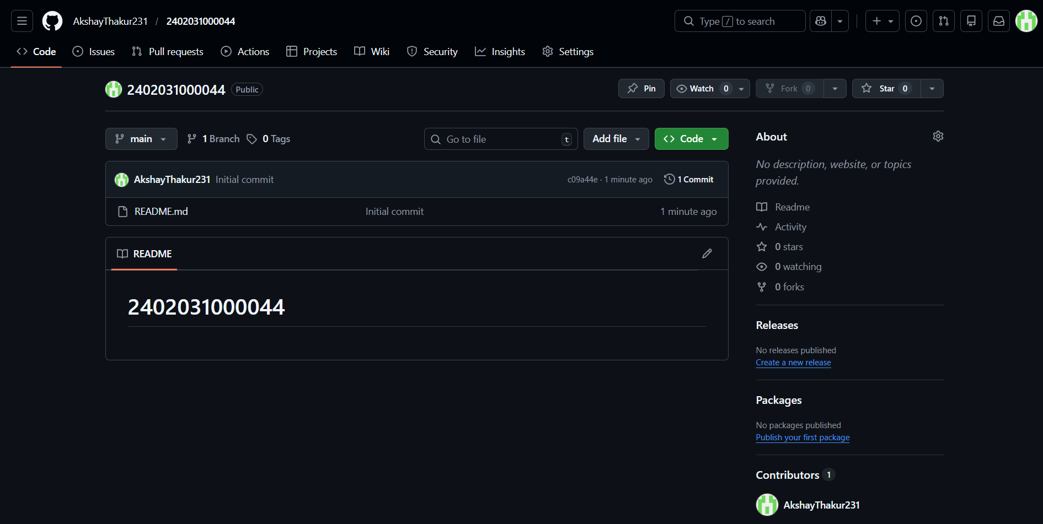

Step 3: Create Assignment_1 Folder
Inside the repository, I added a new folder named Assignment_1. To create this folder on GitHub, I selected 'Add File' and then 'Create New File'. After that, I typed the folder path as Assignment_1/1 which automatically created the folder.

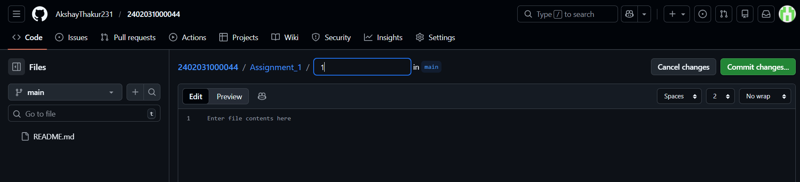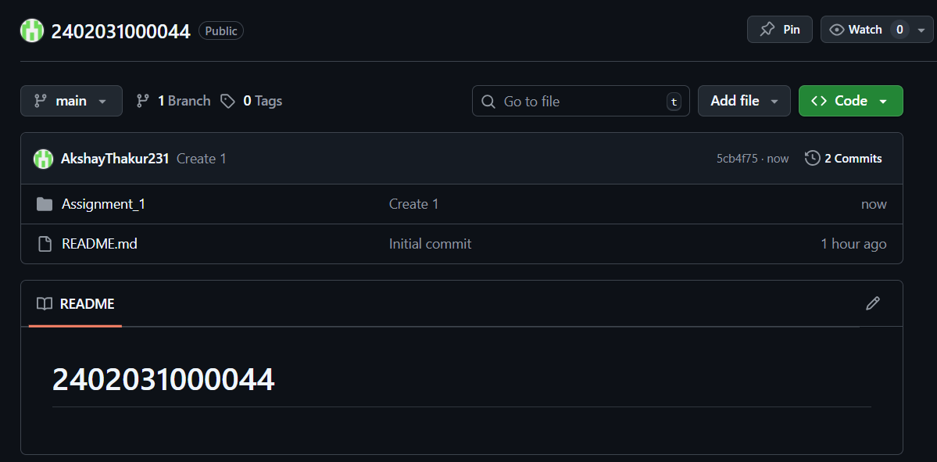

Step 4: Create Assignment_2 Folder
In the same way, I created another folder named Assignment_2/2 in the repository. This folder will be used to upload files related to the second assignment. 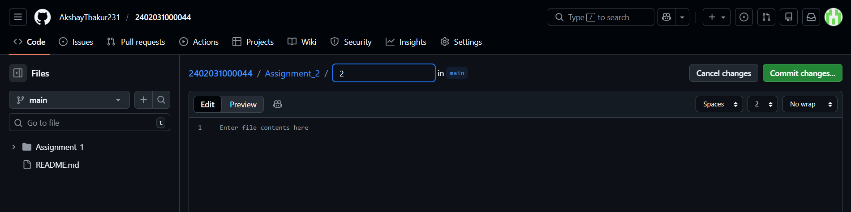
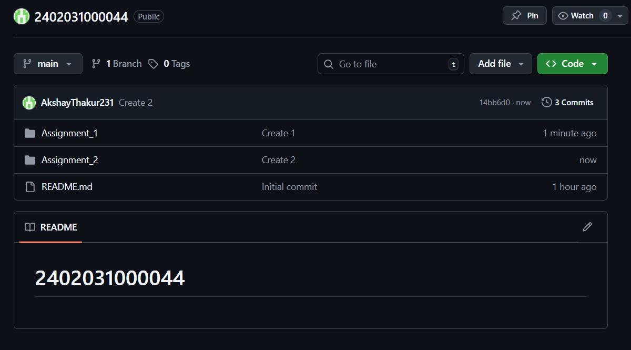
Thank You
Submitted To: Mr. Naimish Patel

